# Department of Computing

# database systems

# Course Instructor: Dr. shams qazi

# Lab 05

## **CS220: DB Systems**

## **Name: Mahum Samar**

# **CMS ID : 290647**

1. **Find average age of students.**

SELECT AVG(age) FROM school.student;

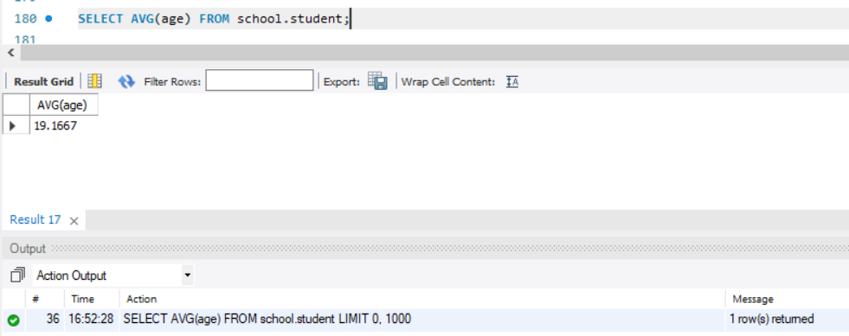

1. **Find the average age of student in course: ‘Organic Chemistry’.**

SELECT AVG(age) FROM school.student

WHERE student.major = 'Organic Chemistry';

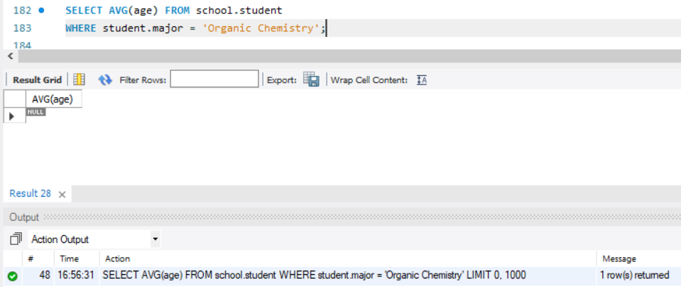

1. **Find eldest student.**

SELECT sname, age FROM school.student

WHERE student.age = (SELECT MAX(age) FROM school.student);

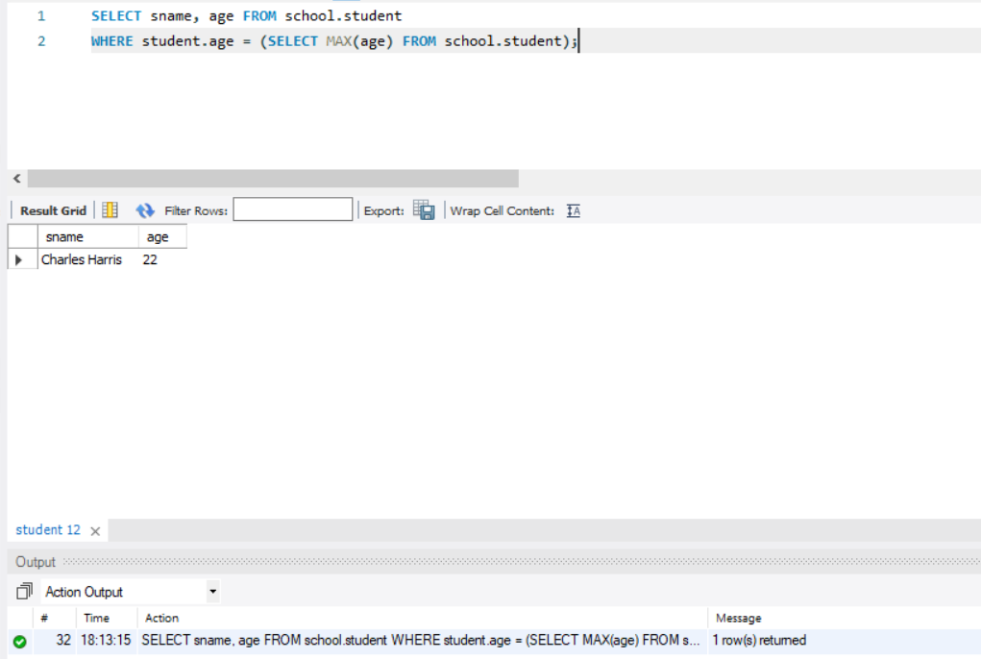

1. **Find youngest student in ‘Electrical Engineering’ major.**

SELECT sname, MIN(age) AS age FROM school.student

WHERE student.major = 'Electrical Engineering';

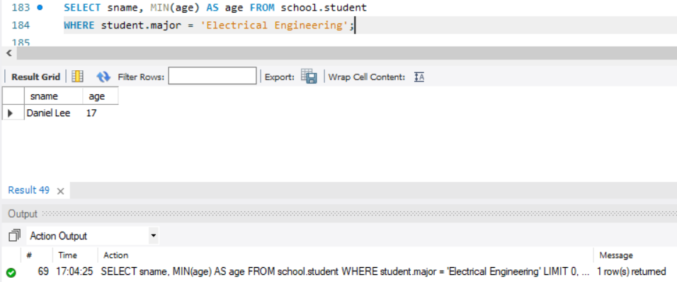

1. **Find eldest student in each level.**

SELECT sname, age, level

FROM school.student

WHERE level = 'FR'

AND age = (SELECT MAX(age) FROM school.student WHERE level = 'FR' )

UNION

SELECT sname, age, level

FROM school.student

WHERE level = 'JR'

AND age = (SELECT MAX(age) FROM school.student WHERE level = 'JR' )

UNION

SELECT sname, age, level

FROM school.student

WHERE level = 'SR'

AND age = (SELECT MAX(age) FROM school.student WHERE level = 'SR' )

UNION

SELECT sname, age, level

FROM school.student

WHERE level = 'SO'

AND age = (SELECT MAX(age) FROM school.student WHERE level = 'SO' )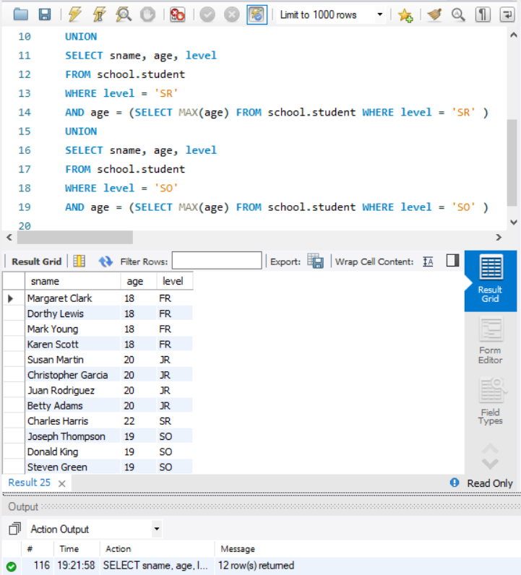

1. **Find average age of students in each level**

SELECT level, AVG(age) AS avg_age

FROM school.student

GROUP BY student.level;

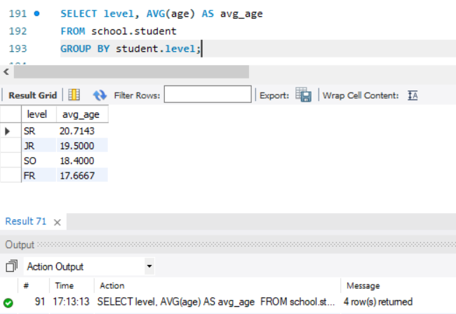

1. **Find the number of distinct class rooms**

SELECT count(DISTINCT room) AS distinct_class_room

FROM School.class;

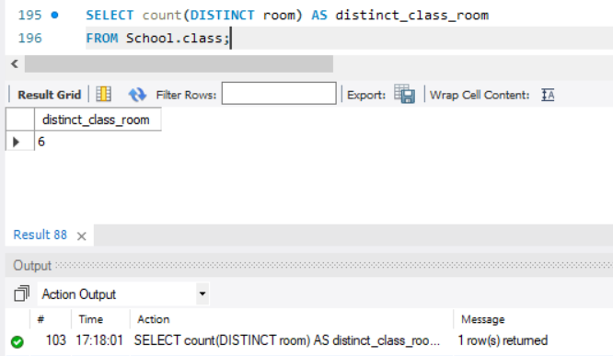

1. **Find the strength of students in each major.**

SELECT major, count(DISTINCT sname) AS strength

FROM School.Student

GROUP BY Student.major;

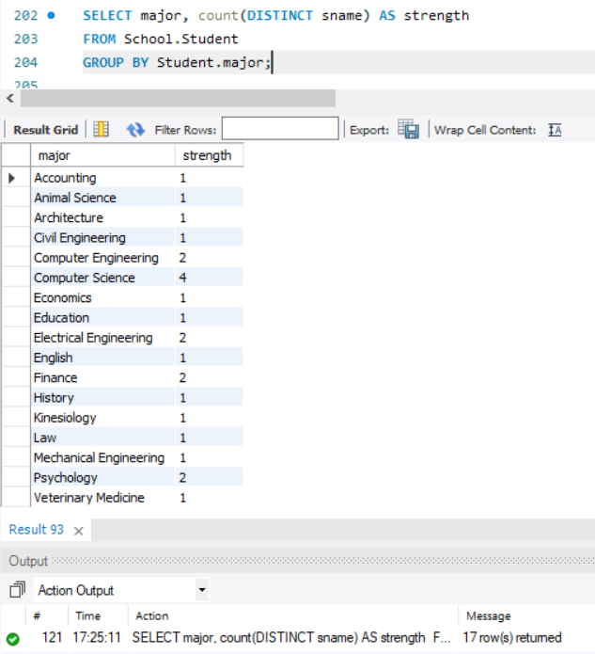

1. **Find strength of students in course: ‘Urban Economics’**

SELECT enrolled.cname, count(DISTINCT sname) AS strength

FROM School.Student, school.enrolled, school.class

WHERE enrolled.cname = class.cname

AND enrolled.cname = 'Urban Economics'

AND student.snum = enrolled.snum;

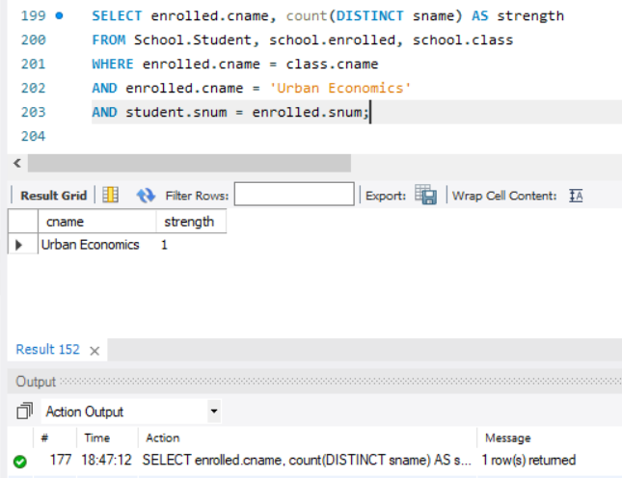

1. **Find the number of courses for student: ‘Karen Scott’.**

SELECT sname, COUNT(enrolled.cname) AS no_of_courses

FROM school.student, school.enrolled

WHERE student.sname = 'Karen Scott'

AND student.snum = enrolled.snum;

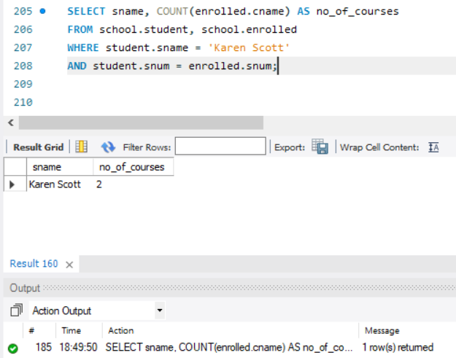

1. **Print the level and the average age of students for that level for all levels except ‘JR’.**

SELECT level, AVG(age) AS age

FROM school.student

WHERE NOT student.level = 'JR'

GROUP BY level;

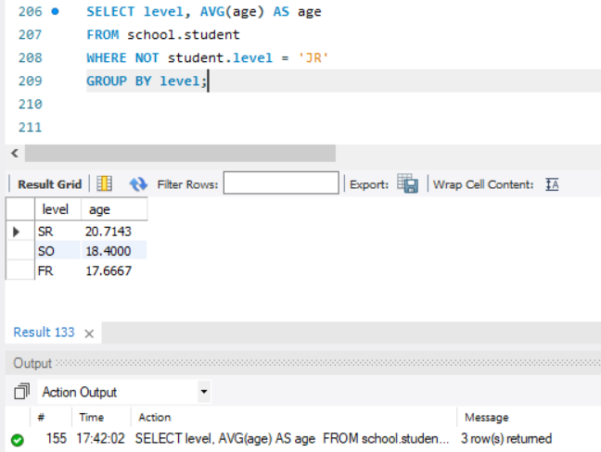

1. **For each faculty member that has taught classes only in room R128, print the faculty**

SELECT faculty.fid, fname, deptid, room

FROM school.faculty

NATURAL JOIN school.class

GROUP BY fname

HAVING class.room = 'R128'

AND COUNT(class.room) = 1;

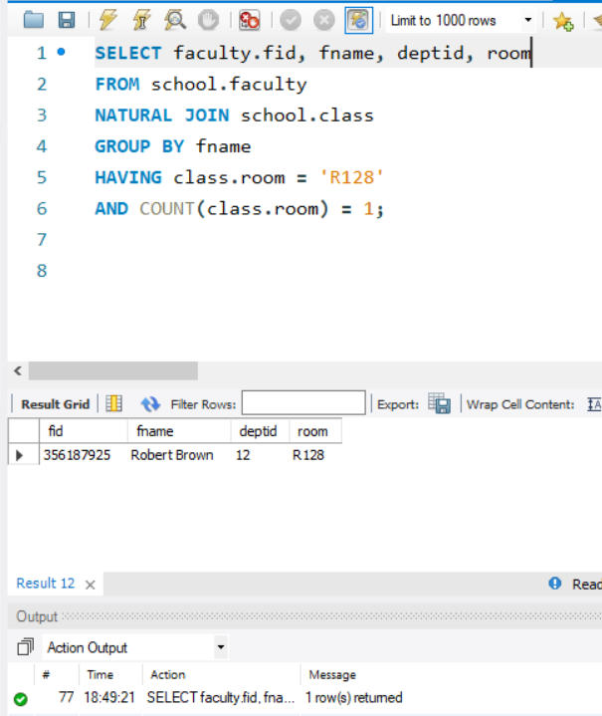

1. **Find the names of all classes and their enrollment strength that have enrollment greater than 2.**

SELECT enrolled.cname, COUNT(enrolled.cname)

FROM school.enrolled, school.student

WHERE enrolled.snum = student.snum

GROUP BY enrolled.cname

HAVING COUNT(enrolled.cname) > 2;

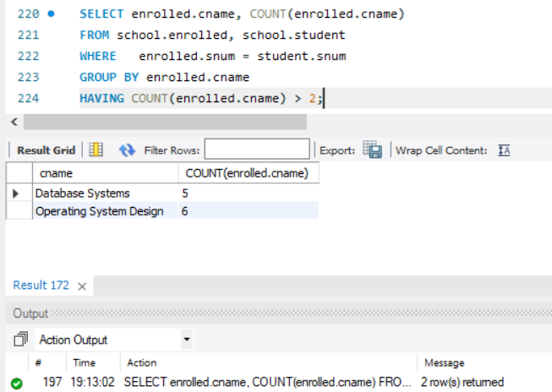

1. **Find the names and strength of classes taught by ‘Ivana Teach’.**

SELECT fname, class.cname, COUNT(enrolled.cname) AS strength

FROM school.class

NATURAL JOIN school.faculty

NATURAL JOIN school.enrolled

WHERE class.fid = faculty.fid

AND faculty.fname = 'Ivana Teach'

GROUP BY class.cname;

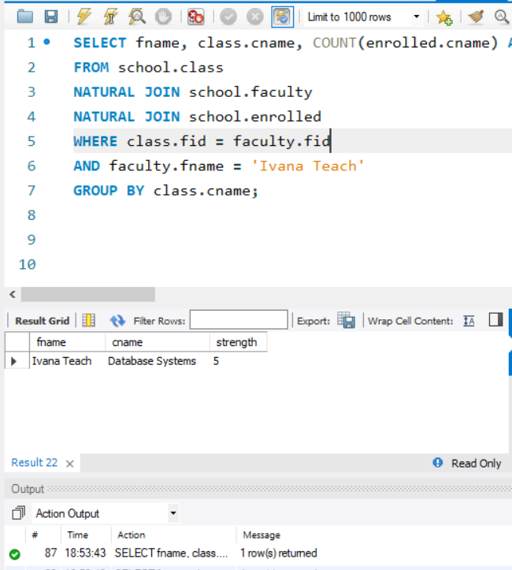

1. **Find the number of faculty members that teach to class ‘database Systems’.**

SELECT fname, cname, COUNT(*) AS noOfFacultyMember

FROM school.faculty, school.class

WHERE faculty.fid = class.fid

AND class.cname ='database systems';

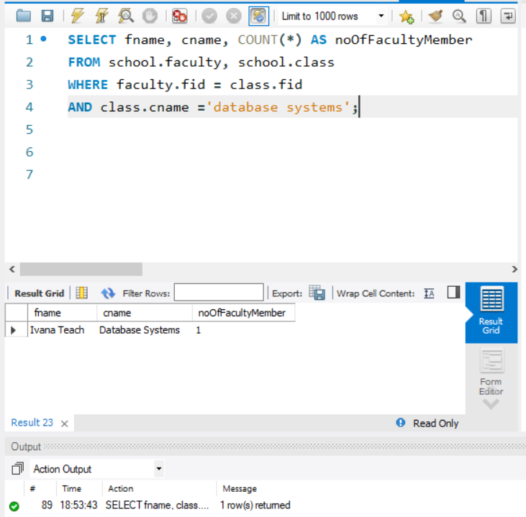

1. **Find the names, strength of faculty members for each class.**

SELECT class.cname,fname,faculty.fid, COUNT(*) AS noOfFacultyMember

FROM school.faculty, school.class

WHERE faculty.fid = class.fid

GROUP BY class.cname;

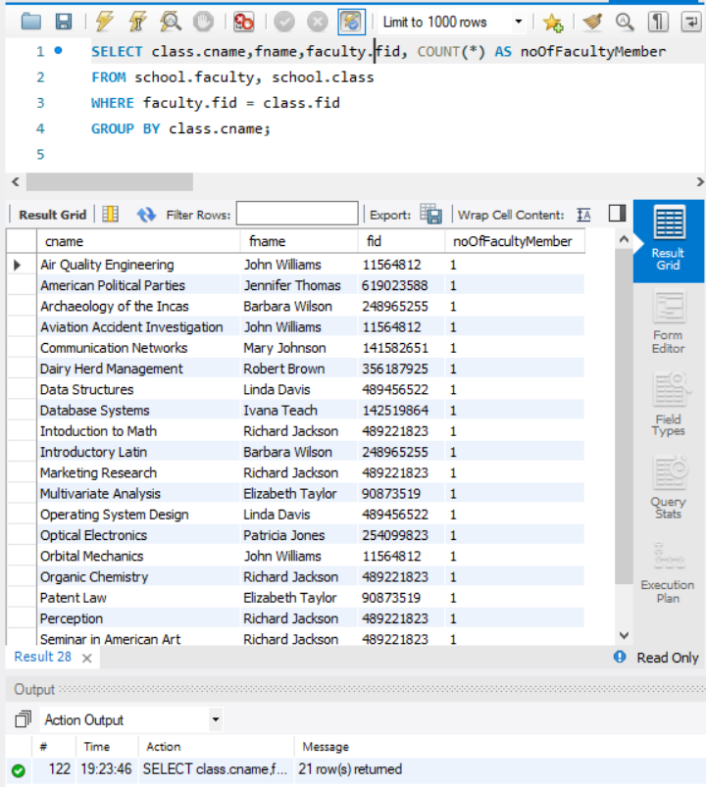

1. **Find the age of youngest student in ‘Database Systems’ class.**

SELECT MIN(age) AS age

FROM school.student, school.enrolled

WHERE student.snum = enrolled.snum

AND enrolled.cname = 'Database Systems';

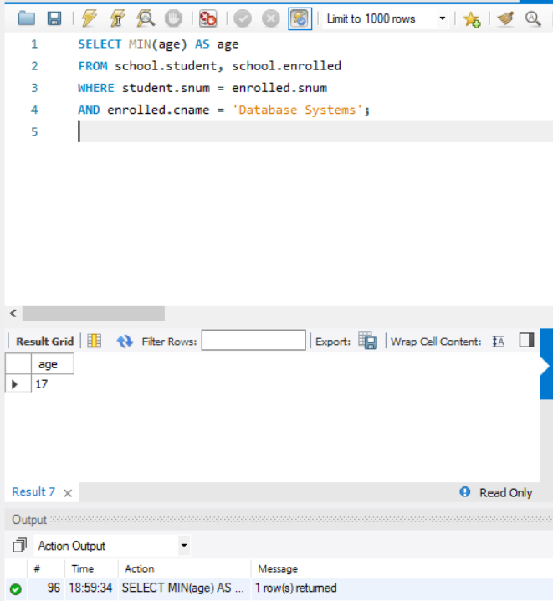

1. **Find the number of classes that occurred in the same room.**

SELECT A.room, COUNT(DISTINCT A.cname) AS no_of_classes_occured

FROM school.class AS A, school.class AS B

WHERE A.room = B.room

GROUP BY A.room;

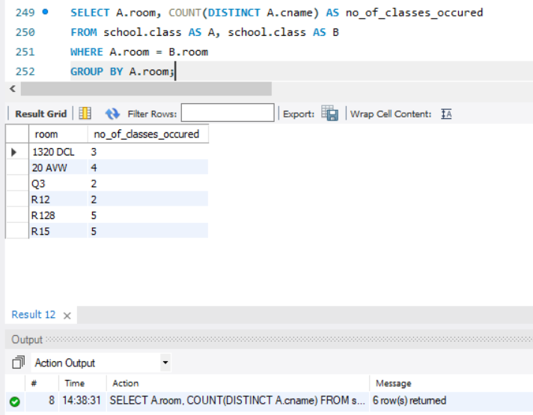

1. **Find the name and strength of students taught by each faculty member.**

SELECT fname, COUNT(student.snum) AS student_strength, class.cname

FROM school.student, school.faculty, school.class, school.enrolled

WHERE faculty.fid = class.fid

AND class.cname = enrolled.cname

AND enrolled.snum = student.snum

GROUP BY fname;

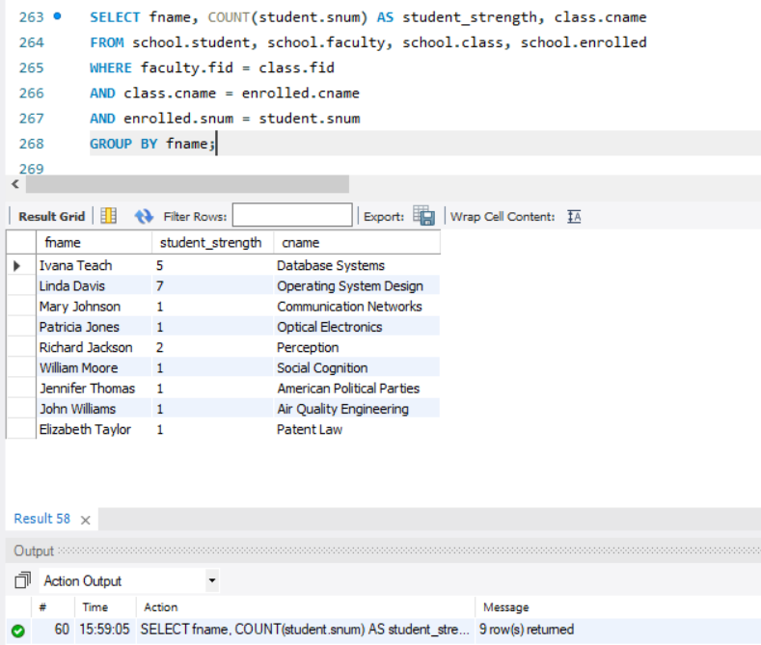

1. **Find the age of eldest student in the class taught by ‘Ivana Teach’.**

SELECT MAX(age) AS age

FROM school.student, school.faculty, school.class, school.enrolled

WHERE fname = 'Ivana Teach'

AND faculty.fid = class.fid

AND class.cname = enrolled.cname

AND enrolled.snum = student.snum;

